Subjects | Monday  3/23/2020 8:00 -2:20 | Tuesday  3/24/2020 8:00 -2:20 | Wednesday  3/25/2020 8:00 -2:20 | Thursday  3/26/2020 8:00 -2:20 | Friday  3/27/2020 8:00-2:20
 | Come to school on time | Family Engagement  Every Tuesday  2:30-3:30 | ELA TEST  DAY 1 | ELA TEST  DAY 2
Reading and Writing Workshop  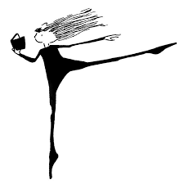 | Read EarthShaker’s Bad Day for 15 minutes and answer the reading question. After, read your own fiction book for 30 mins. and record your reading on your reading log.  Reading Question- Identify 3 character traits to describe Poseidon. Use Text Evidence to support. HWBK | Read Read The Monster Beneath the Sea for 15 minutes and answer the reading question. After, read your own fiction book for 30 mins. and record your reading on your reading log.  Reading Question-Describe HOW Namazu and Poseidon are alike. HWBK | Read Read The Monster Beneath the Sea for 15 minutes and answer the reading question. After, read your own fiction book for 30 mins. and record your reading on your reading log. | Read Non-Fiction 45 minutes and record your reading on your reading log. | Read Non-Fiction 45 minutes and record your reading on your reading log.
Envision Math 2.0 | Math Worksheet- Review Topic 15  Solve using any strategy of your choice.  A.78 × 10  HWBK | Topic 15 Assessment  Math Problem #17  See back for example #17  HWBK | Math Worksheet- 16-1  Solve and check your work  78,007 107,905  - 7,278 +136,890  Round your answer to the nearest thousand  HWBK | Math Worksheet 16-2  www.sheppardsoftware.com | Math- Worksheet 16-3  www.sheppardsoftware.com
Science  _______  Social Studies | HWBK-- ALL WEEK | What form of energy is being used when a person pushes a wooden block  across the floor?  A mechanical B magnetic  C sound D electrical | Which physical structure would best help a bear to survive a winter in  New York State?  A big ears B black nose  C thick fur D brown eyes |  | Since green plants make their own food, they are called  A predator B prey  C decomposers  D producers
Please check/ sign H.W. | Parent Signature  X______________ | Parent Signature  X__________________ | Parent Signature  X__________________ | Parent Signature  X__________________ | Parent Signature  X______________
Date | Book Title | Author | Start Page  (Number) | End Page  (Number) | Minutes Read | Book Genre | Parent Signature
Monday  3/23 |  |  |  |  |  | Fiction Book
Tuesday  3/24 |  |  |  |  |  | Fiction Book
Wednesday  3/25 |  |  |  |  |  | Fiction Book
Thursday  3/26 |  |  |  |  |  | Non-Fiction Book
Friday  3/27 |  |  |  |  |  | Non-Fiction Book
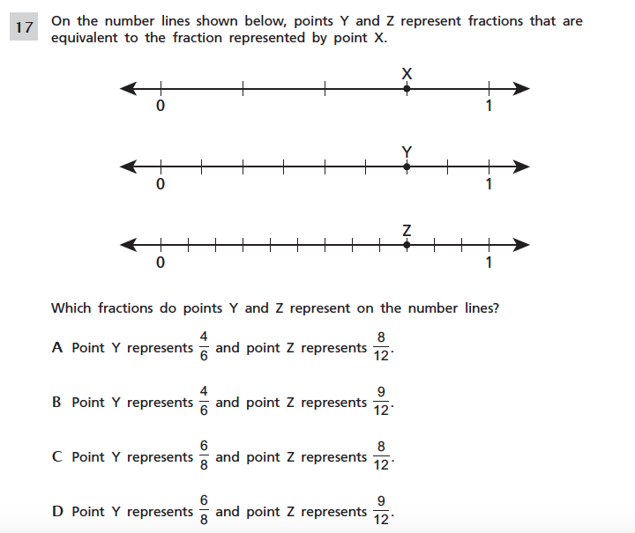
Test Scores and Quiz
Reading Test Score | Test Date | Parent Signature
Math Test | Test Date | Parent Signature
S/S- Science Test | Test Date | Parent Signature

