Subjects | Monday  3/9/2020 8:00 -2:20 | Tuesday  3/10/2020 8:00 -2:20 | Wednesday  3/11/2020 8:00 -2:20 | Thursday  3/12/2020 8:00 -2:20 | Friday  3/13/2020 8:00-2:20
 | Come to school on time | Parent Workshop!  ELA State Test Prep  2:30-3:30 |  | Math Websites to visit  www.aaamath.com  www.ixl.com | Last day turn in “Mulan” trip permission slip!
Reading and Writing Workshop | Read EarthShaker’s Bad Day for 15 minutes and answer the reading question. After, read your own fiction book for 30 mins. and record your reading on your reading log.  Reading Question-What problems did Poseidon face if he wanted to be the ruler of Attica? HWBK | Read EarthShaker’s Bad Day for 15 minutes and answer the reading question. After, read your own fiction book for 30 mins. and record your reading on your reading log.  Writing- Work on your essay tonight Follow your essay frame. | Read EarthShaker’s Bad Day for 15 minutes and answer the reading question. After, read your own fiction book for 30 mins. and record your reading on your reading log.  Writing- Work on your essay tonight Follow your essay frame. | Read Non-Fiction 45 minutes and record your reading on your reading log.  Vocabulary- Write an Antonym for the following words.  - tense  - violent  - energized  HWBK | Read Non-Fiction 45 minutes and record your reading on your reading log.
Envision Math 2.0 | Math Worksheet- 14-1  Solve using any strategy of your choice.  A.29 × 56  HWBK | Math worksheet- 14-2  #31 MATH PROBLEM  HWBK | Math Worksheet-14-3  Solve and check your work  30,000 567,905  - 2,678 +236,890  HWBK | Math Worksheet-14-4  www.sheppardsoftware.com Convert Improper Fractions | Math- practice  www.sheppardsoftware.com Adding Fractions
Science  _______  Social Studies | Describe two negative effects a factory might have on the organisms living in the area.  HWBK-- ALL WEEK | Trains, cars, and airplanes help humans travel quickly. What is one negative effect that the use of these types of transportation has on the environment? | Which process occurs when ocean waves drop seashells on a beach?  A condensation B deposition  C classification D rotation | Which two terms are used to describe weather?  A wind direction and amount of erosion  B gravity and amount of rain  C groundwater and cloud cover  D air temperature and wind speed
Please check/ sign H.W. | Parent Signature  X______________ | Parent Signature  X__________________ | Parent Signature  X__________________ | Parent Signature  X__________________ | Parent Signature  X______________
Date | Book Title | Author | Start Page  (Number) | End Page  (Number) | Minutes Read | Book Genre | Parent Signature
Monday  3/9 |  |  |  |  |  | Fiction Book
Tuesday  3/10 |  |  |  |  |  | Fiction Book
Wednesday  3/11 |  |  |  |  |  | Fiction Book
Thursday  3/12 |  |  |  |  |  | Non-Fiction Book
Friday  3/13 |  |  |  |  |  | Non-Fiction Book
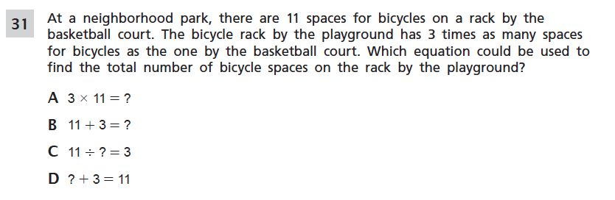
Test Scores and Quiz
Reading Test Score | Test Date | Parent Signature
Math Test | Test Date | Parent Signature
S/S- Science Test | Test Date | Parent Signature

